User Manual

1. Startup page will display as below.

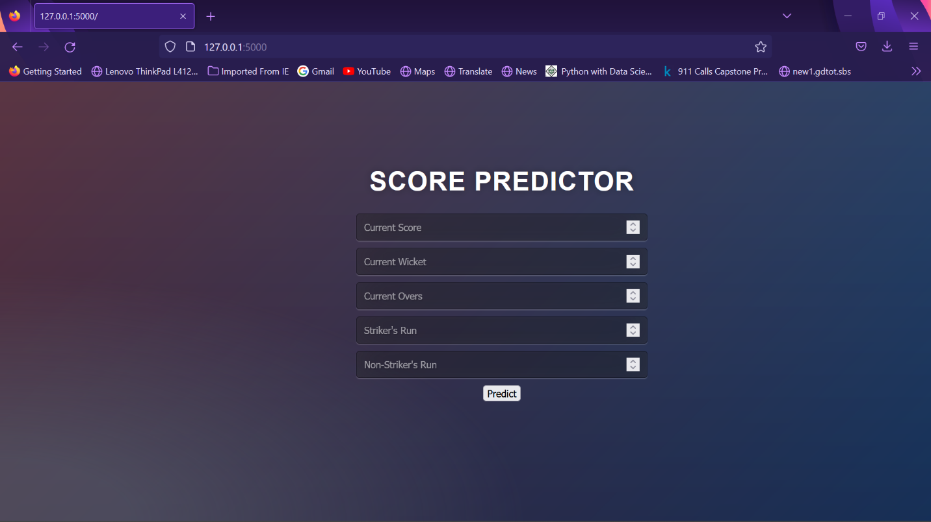

1. Enter data for Prediction

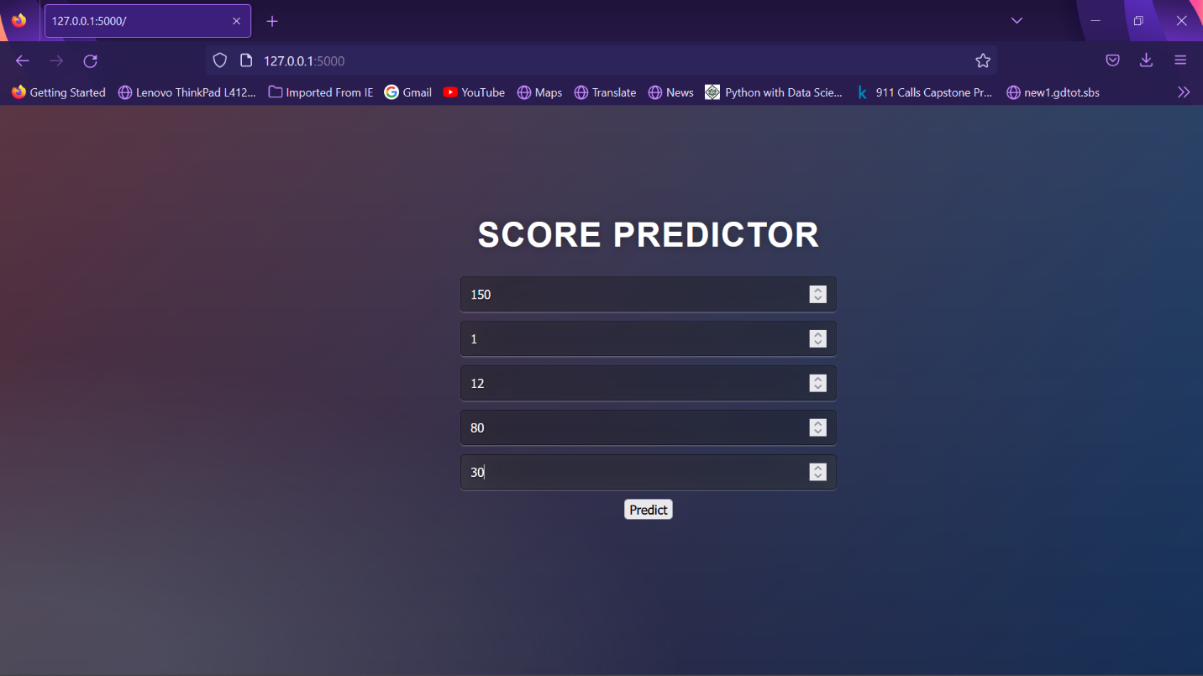

1. Press Ctrl+Enter to analyze the Prediction.
2. The type of the Prediction input will be displayed as shown below.

